**Problem 1:**

% Lab 3

% Problem 1

Nx = -10:4; % positions of x

No_x = length(Nx); % number of elements in x

x = ones(1, No_x); % magnitudes of x

Nh = 0:15; % positions of h

No_h = length(Nh); % number of elements in h

h = 2.^Nh; % magnitudes of h

y = conv(x,h); % convolution results of x and h

Ny = (min(Nx) + min(Nh)): (max(Nx) + max(Nh)) ; % number of elements in y

figure(1)

subplot(3,1,1)

stem(Nx, x)

xlim([-15 15])

subplot(3,1,2)

stem(Nh,h)

xlim([-15 15])

subplot(3,1,3)

stem(Ny, y)

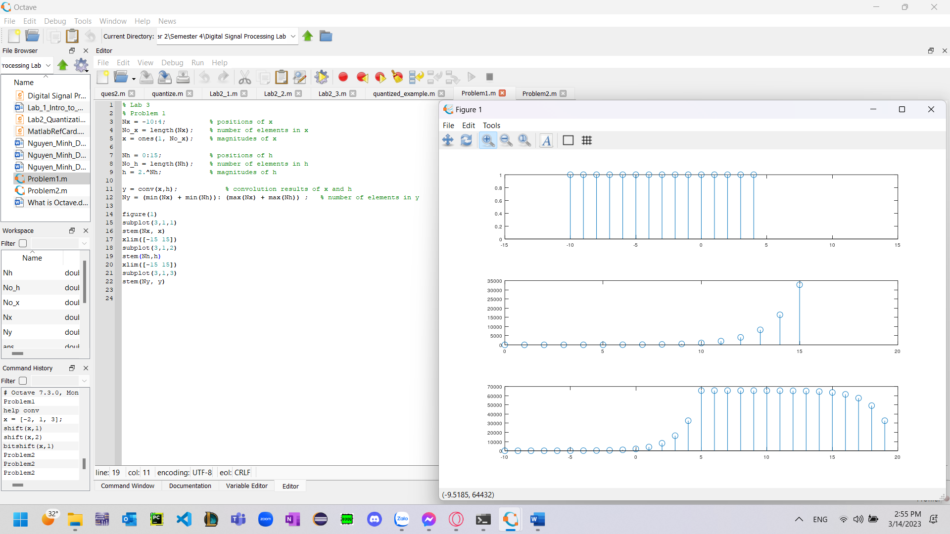

**Problem 2:**

Nx = 0:5; % positions of x

No_x = length(Nx); % number of elements in x

x = ones(1, No_x); % magnitudes of x

Nh = -10:10; % positions of h

No_h = length(Nh); % number of elements in h

h = e.^(-Nh); % magnitudes of h

function [output] = myConvolve(x, h)

% Get length of input and kernel

lenX = length(x);

lenH = length(h);

% Initialize output vector with zeros

output = zeros(1, lenX + lenH - 1);

% Loop over each index in the output vector

for n = 1:length(output)

% Compute the current output value

sum = 0;

for k = 1:lenH

if (n-k+1 > 0) && (n-k+1 <= lenX)

sum += h(k) * x(n-k+1);

end

end

output(n) = sum;

end

end

myConvolve(x, h)

**Problem 3:**

clc;

clear;

x=input('enter 1st sequence: ');

a=input('enter the initial time index of 1st sequence: ');

x_n=a:length(x)-1+a;

h=input('enter 2nd sequence: ');

b=input('enter the initial time index of 2nd sequence: ');

h_n=b:length(h)-1+b;

m=min(x_n)+min(h_n):max(x_n)+max(h_n);

h1=[h zeros(1,length(x))];

% h1_n=min(h_n):length(h1)-1+min(h_n);

x1=[x zeros(1,length(h))];

% x1_n=min(x_n):length(x1)-1+min(x_n);

y= zeros(1,length(m));

for n=1:length(m)

for k=1:n

y(n)=y(n)+x1(k)*h1(n-k+1);

end

end

y

subplot(3,1,1);

stem(x_n,x);

title('1st Sequence');

subplot(3,1,2);

stem(h_n,h);

title('2nd Sequence')

subplot(3,1,3);

stem(m,y);

title('Convoluted Sequence');

%%function for convolution of two finite duration sequence

function [y,m] = myconv(x,a,h,b)

x_n=a:length(x)-1+a;

h_n=b:length(h)-1+b;

m=min(x_n)+min(h_n):max(x_n)+max(h_n);

h1=[h zeros(1,length(x))];

% h1_n=min(h_n):length(h1)-1+min(h_n);

x1=[x zeros(1,length(h))];

% x1_n=min(x_n):length(x1)-1+min(x_n);

y= zeros(1,length(m));

for n=1:length(m)

for k=1:n

y(n)=y(n)+x1(k)*h1(n-k+1);

end

end

end

myconv(x,a,h,b)

